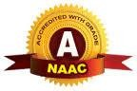
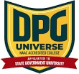
DPG DEGREE COLLEGE

(Approved by AICTE & Affiliated to MDU)
Recognized 2(f) by UGC & Accredited with ‘A’ Grade by NAAC
Sector-34, Near Marble Market, Gurugram 122001

DIWALI CELEBRATION 2025

Date-17 October, 2025

Date: 17 October, 2025
Venue: Dpg Degree College Time: 1:15 pm onwards

The festival of lights, Diwali, was celebrated with great enthusiasm and joy at DPG Degree College on 17th October 2025. The event aimed to promote cultural harmony, student participation, and festive spirit within the campus. The college premises were beautifully decorated with diyas, rangoli, and lights, creating a vibrant and cheerful atmosphere

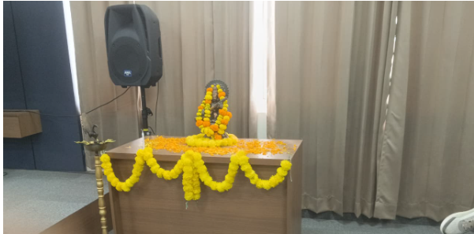

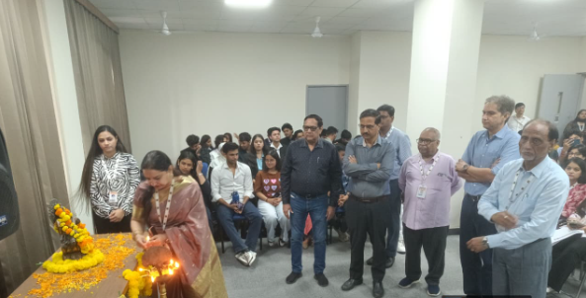

A competition was also organised, in which students participated with great zeal and creativity. The best performances were appreciated, and certificates were awarded to the students who secured second and third positions for their excellent participation.

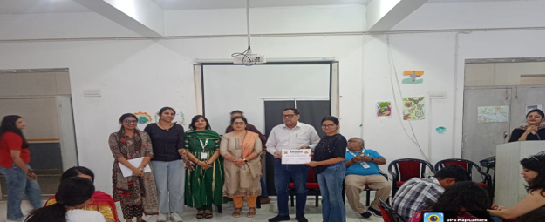

The following events were also organized as part of the Diwali Mela:
- 🎪 Diwali Mela Stalls: Various stalls were set up by students offering handmade crafts, festive décor, sweets, and snacks.
- 🎭 Cultural Performances: Students showcased their talents through dance, music, and drama based on Diwali themes.
- 🎨 Rangoli Competition: Colorful and creative rangoli designs were displayed, reflecting cultural richness and artistry.
- 🎁 Best Stall Awards: Winners were felicitated for their creativity, decoration, and festive presentation.
- 📸 Photo Booth & Decoration Zone: A dedicated photo area was arranged for students to capture memorable moments.

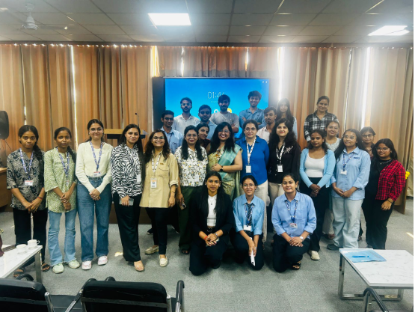

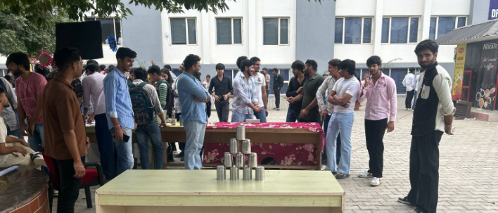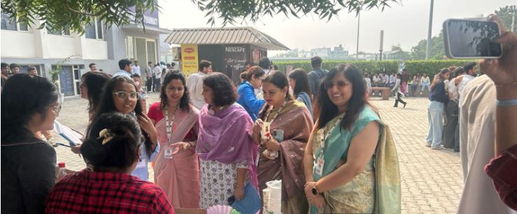

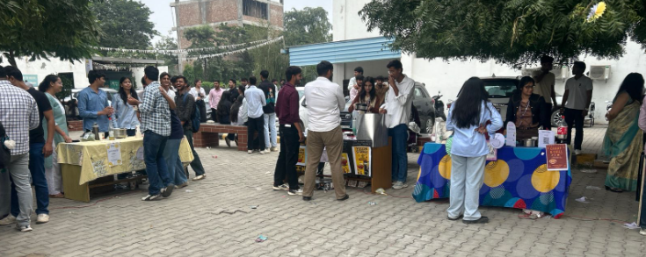

. Highlights of the Celebration
- The participation from students across all departments was remarkable.
- The Diwali Mela promoted entrepreneurship and teamwork as students managed stalls independently.
- Eco-friendly Diwali awareness was spread through posters and announcements encouraging the use of diyas and avoiding firecrackers.

Ms. Navpreet Kaur Dr. S.S. Boken
(Convener, Cultural Committee) (Principal)
Asst. Professor, Department of Science DPG Degree College

Dr. Kashmira Mathur
Assistant Professor, Department of Management

Ms. Kajal Gupta
Assistant Professor, Department of Management

Ms. Anjali Paliwal
Assistant Professor, Department of Management

Ms. Shruti Bhalla
Assistant Professor, Department of Computer Science

