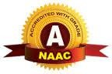
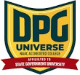
DPG DEGREE COLLEGE

(Approved by AICTE & Affiliated to MDU)
Recognized 2(f) by UGC & Accredited with ‘A’ Grade by NAAC
Sector-34, Near Marble Market, Gurugram 122001

KARWACHAUTH CELEBRATION 2025

Date-9 October, 2025

Date: 9 October, 2025
Venue: Dpg Degree College Time: 1:15 pm onwards

The festival of Karva Chauth was celebrated with great enthusiasm and joy at DPG Degree College, Gurgaon on 9th October 2025. The celebration created a vibrant and festive atmosphere, bringing together teachers and students to share in the cultural spirit of the occasion.
Many students showcased their talents through various performances such as singing, dancing, and mehndi art. One of the main highlights of the event was the mehndi activity, where students beautifully applied mehndi on the hands of the teachers, making the celebration even more special and joyous.

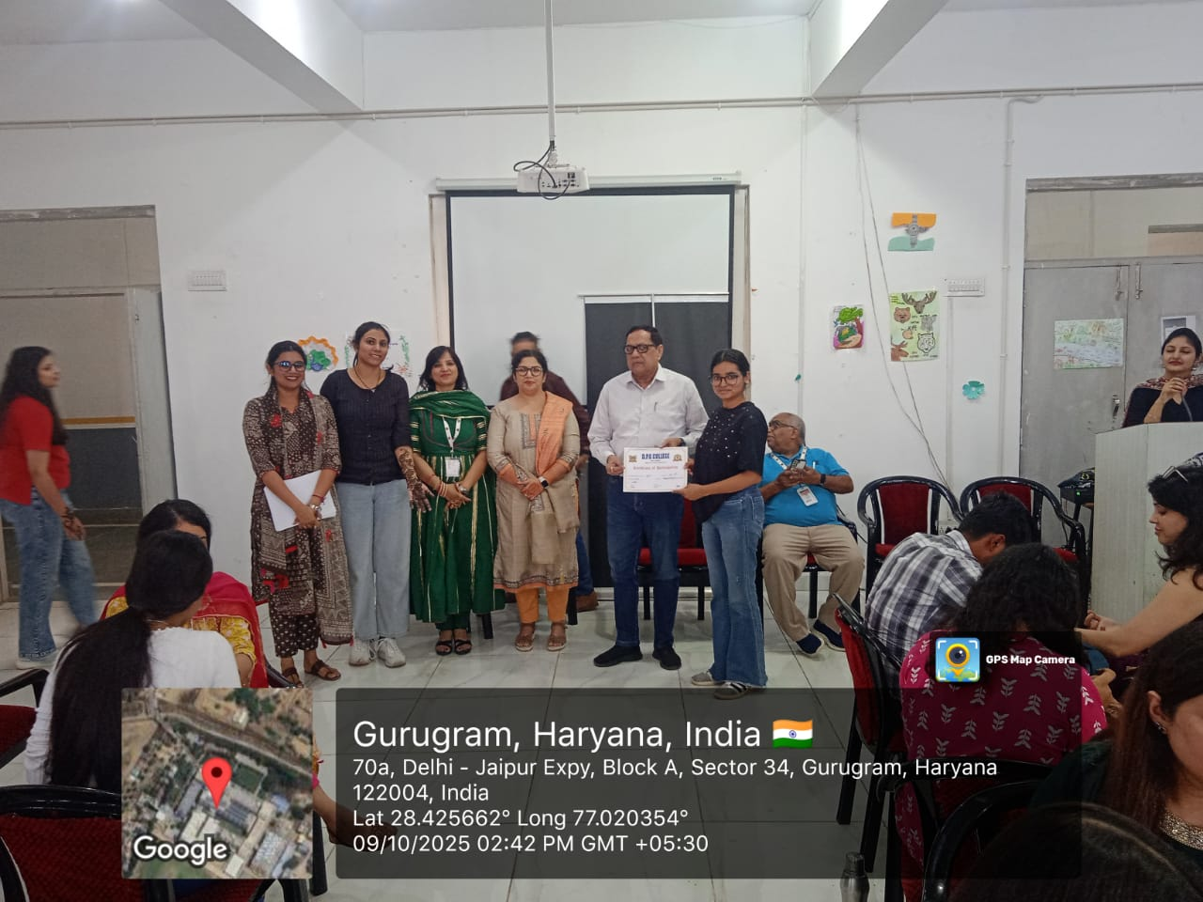

A competition was also organized, in which students participated with great zeal and creativity. The best performances were appreciated, and certificates were awarded to the students who secured second and third positions for their excellent participation.

Overall, the Karva Chauth celebration was a wonderful and memorable event for both teachers and students. It not only showcased the artistic talents of the students but also strengthened the bond between teachers and learners, reflecting the true essence of culture, respect, and togetherness.

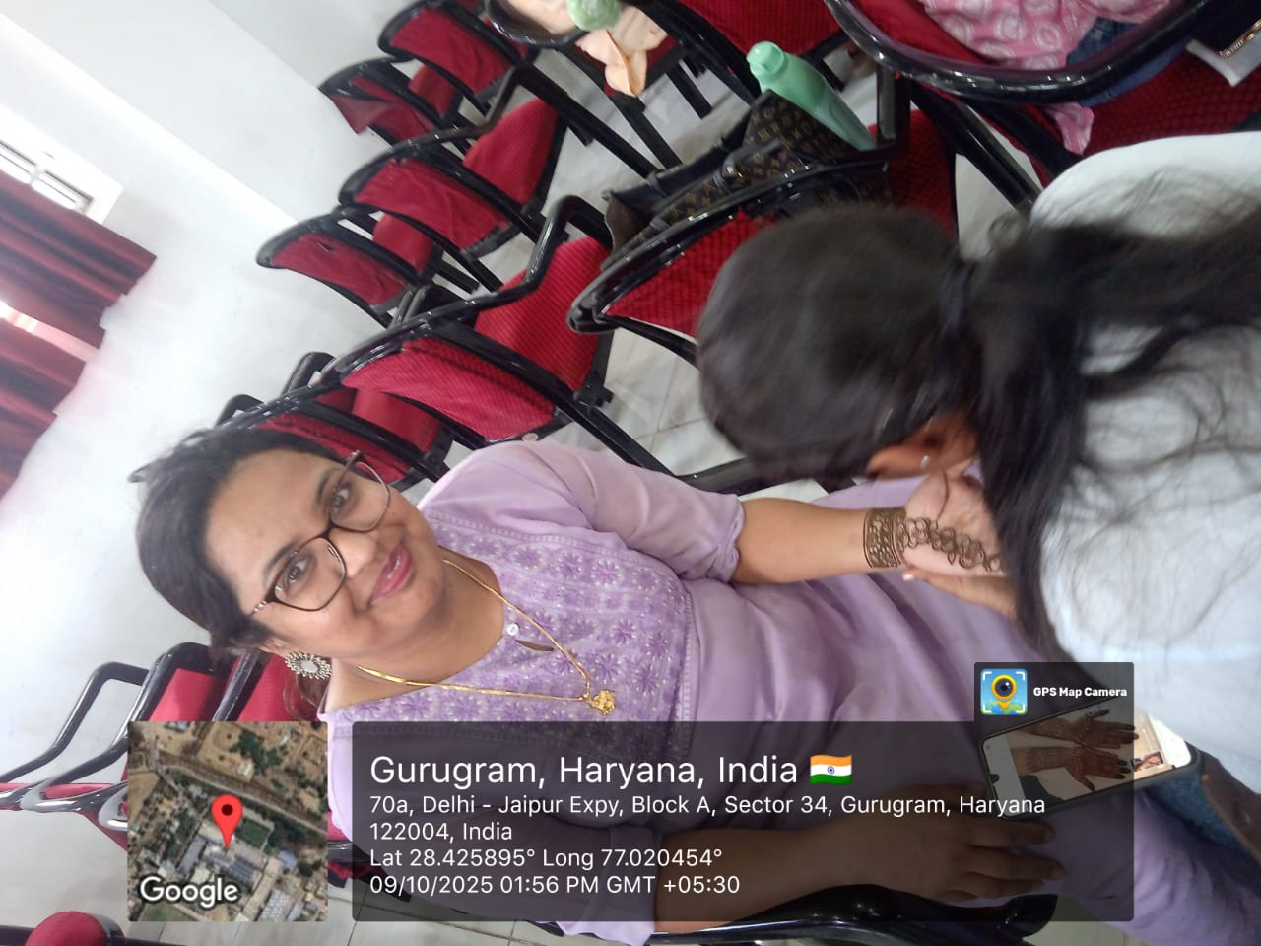

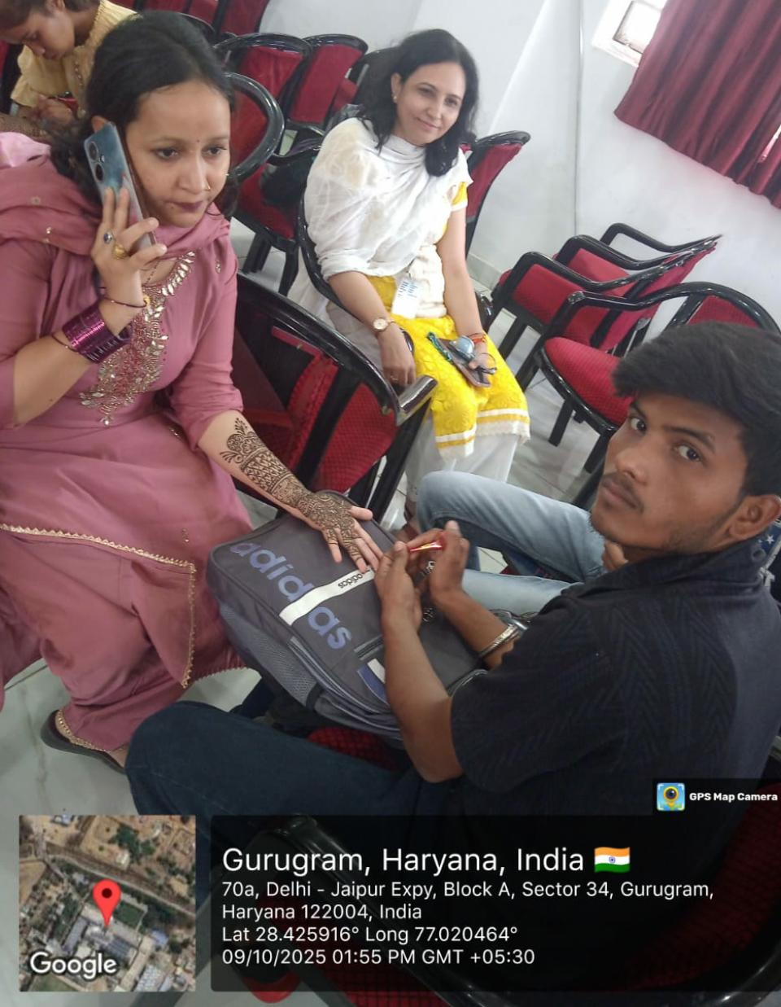

The celebration also included a competition segment, where students participated enthusiastically in various activities such as mehndi design, singing, and dance performances. Their active involvement and creative expressions made the event truly vibrant and engaging. After careful judgment, students who displayed exceptional talent were awarded first, second, and third prizes along with certificates of appreciation. These recognitions not only motivated the participants but also encouraged others to take part in future cultural programs. Such events play a vital role in enhancing students’ creativity, building their confidence, and providing them a platform to showcase their hidden talents, thereby contributing to their overall personality development.

Ms. Navpreet Kaur Dr. S.S. Boken
(Convener, Cultural Committee) (Principal)
Asst. Professor, Department of Science DPG Degree College

Dr. Kashmira Mathur
Assistant Professor, Department of Management

Ms. Kajal Gupta
Assistant Professor, Department of Management

Ms. Anjali Paliwal
Assistant Professor, Department of Management

Ms. Shruti Bhalla
Assistant Professor, Department of Computer Science

