

Ref. No.: ________________
Report on Manovation – The Management Fest
Date: 31st October 2025
Time: 09:30 AM – 01:00 PM
Venue: F-Block, DPG Degree College
Faculty Coordinator: Dr. Kashmira Mathur

Objectives of the Fest

The main objectives of Manovation – The Management Fest were to showcase managerial talent, creativity, and entrepreneurial skills among students. It aimed to provide a platform for practical learning through competition and teamwork, to encourage innovation, confidence, and leadership qualities, and to bridge classroom knowledge with real-world business simulations.
Activities Conducted
Start-Up Pitch: In this activity, teams presented innovative and feasible business ideas that demonstrated entrepreneurial thinking and problem-solving abilities. Participants worked on identifying market gaps, financial feasibility, and implementation strategies while confidently pitching their ideas. The event nurtured innovation, analytical thinking, and business communication skills among students.
Judging criteria included innovation, viability, financial sense, and communication.
Winners:
1st – Akshat 2nd – Abhishek 3rd – Ansh and Arun

Corporate Walk : Participants confidently walked the ramp dressed in professional corporate attire, portraying elegance, confidence, and a strong corporate demeanour. The event aimed to develop personality, grooming, and presentation skills essential in the professional world. It also helped students understand the importance of first impressions and professional conduct in a workplace setting. Judging criteria included professionalism, presentation, and body language.
Winners (Girls): 1st – Kritika 2nd – Anjali 3rd – Ashu
Winners (Boys): 1st – Ankit 2nd – Manish 3rd – Shubham and Pranav
Poster Presentation: With the theme “Future of Management & Innovation,” students presented creative and visually appealing posters showcasing futuristic management ideas and innovative concepts. The event encouraged analytical thinking and creativity, allowing students to visualize future trends in the corporate world. It was an excellent blend of design thinking and managerial insight. Judging criteria included creativity, relevance, clarity, and visual impact.
Winners:
1st – Rakhi 2nd – Renu, Sania, and Vaani 3rd – Khushi

Marketing Mela – Product Stall & Selling Challenge: This was one of the most vibrant events of the day, where teams set up product stalls and implemented creative marketing and sales strategies to attract buyers. Students demonstrated entrepreneurial spirit, innovative thinking, and teamwork while promoting and selling their products. The activity provided hands-on experience in branding, customer interaction, and real-world business practices. Judging criteria included creativity, sales pitch, branding, innovation, and teamwork.
Winners:
1st-Hanushka,Shilpi,and Jagyanseni ,2nd – Gaurav and Deepak, 3rd – Ansh, Gazal, Nisha, and Anjali

Role Play: Students enacted real-world management and HR scenarios, including negotiations, interviews, and crisis handling. This activity provided them with an opportunity to experience practical business situations and enhance their communication and problem-solving skills. The event highlighted the importance of teamwork, adaptability, and strategic thinking in managerial roles.

Ad-Mad Show: Students showcased their creativity by developing and presenting unique, engaging, and humorous advertisements. Each team came up with innovative concepts that reflected originality and strong marketing instincts. The event encouraged students to think like advertisers, emphasizing the importance of creativity, clarity, and impactful delivery.

Newsletter Launch – Chronicle: A major highlight of the event was the official launch of the department’s newsletter titled “Chronicle.” The newsletter aims to capture the essence of departmental activities, student achievements, and creative contributions throughout the academic year. It serves as a platform to celebrate innovation, talent, and collaboration within the department. The launch of Chronicle marked a new beginning in documenting and showcasing the vibrant culture of learning and growth among students and faculty members.
The fest witnessed enthusiastic participation across departments. Medals and certificates were awarded to the winners of each events as a token of encouragement. The fest significantly enhanced students’ confidence, creativity, and managerial acumen. It provided valuable practical exposure to real-world business challenges and helped bridge the gap between theoretical learning and practical implementation.

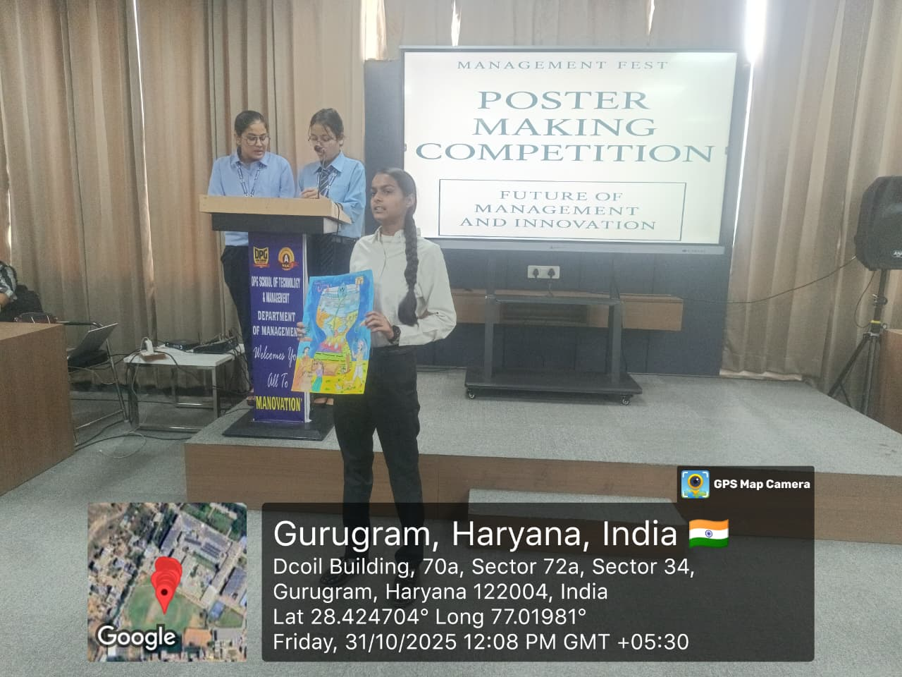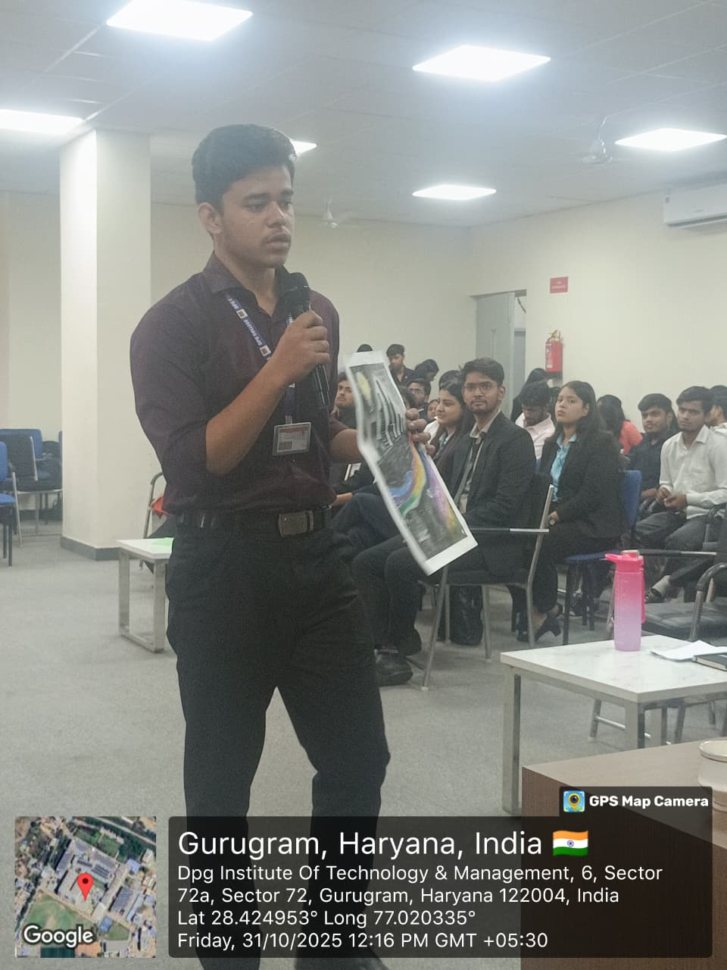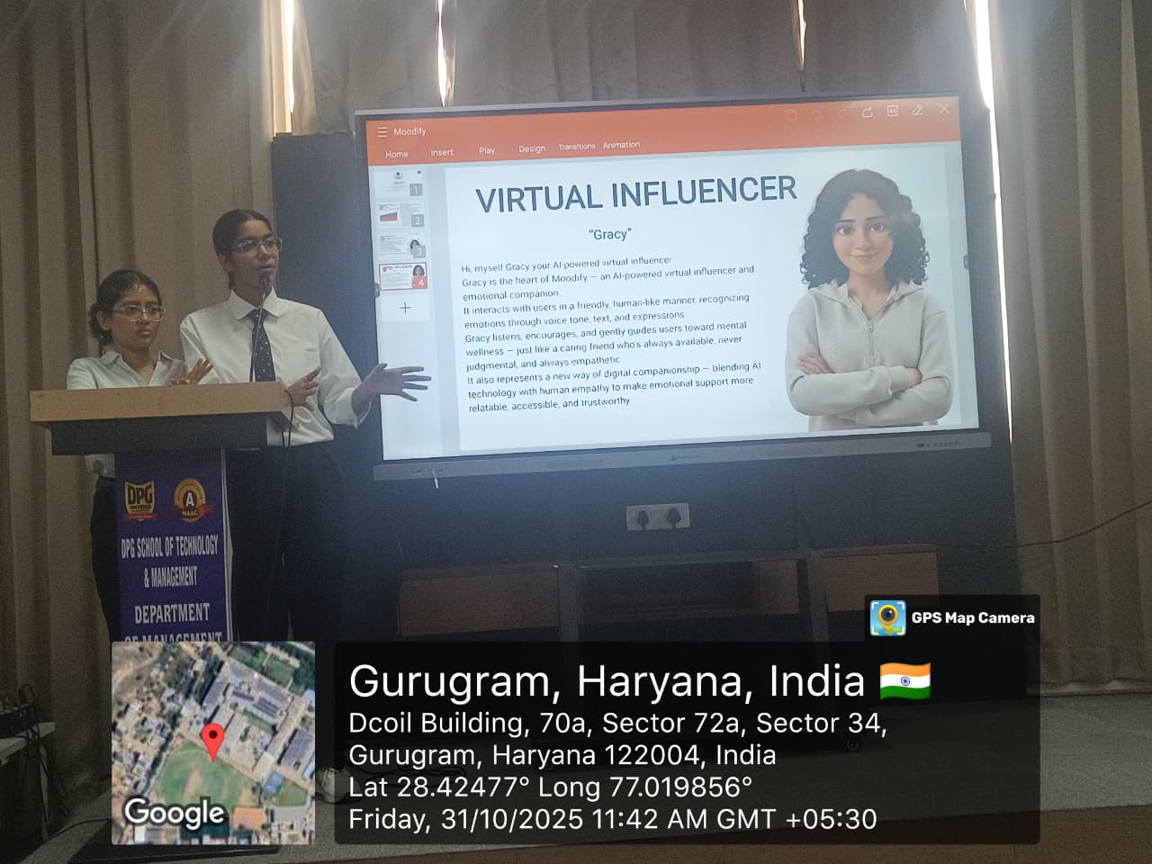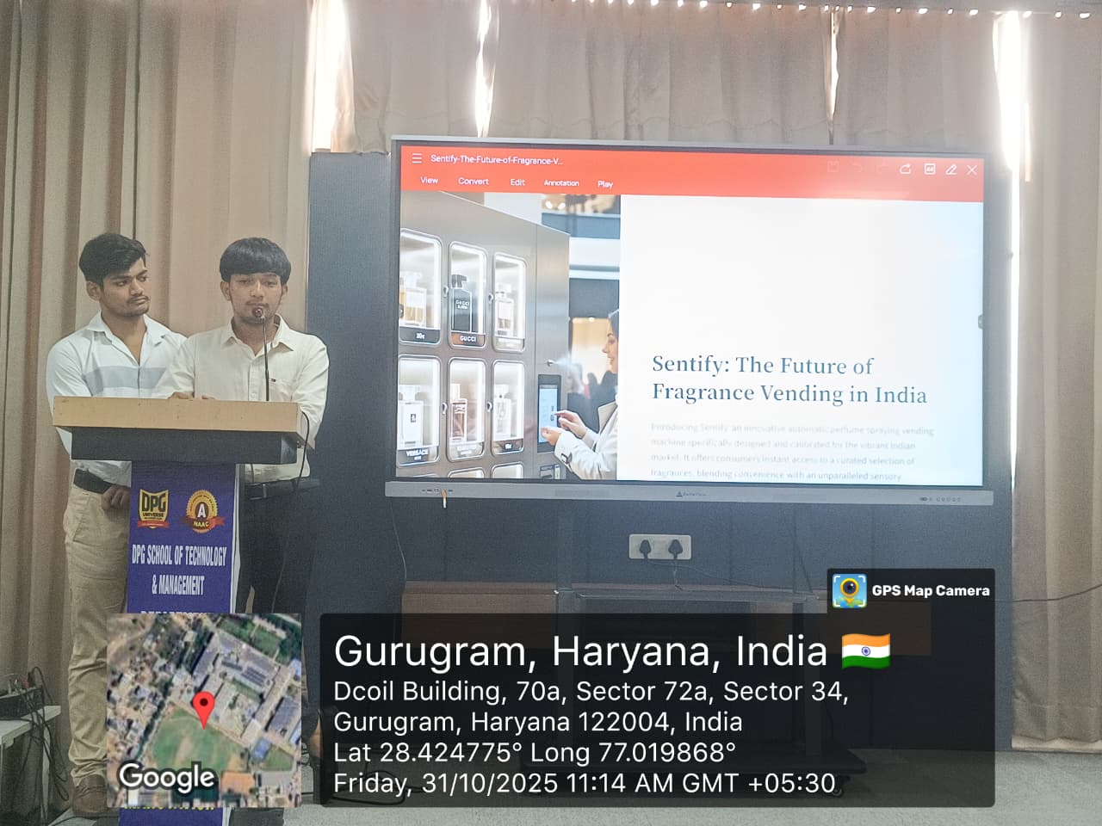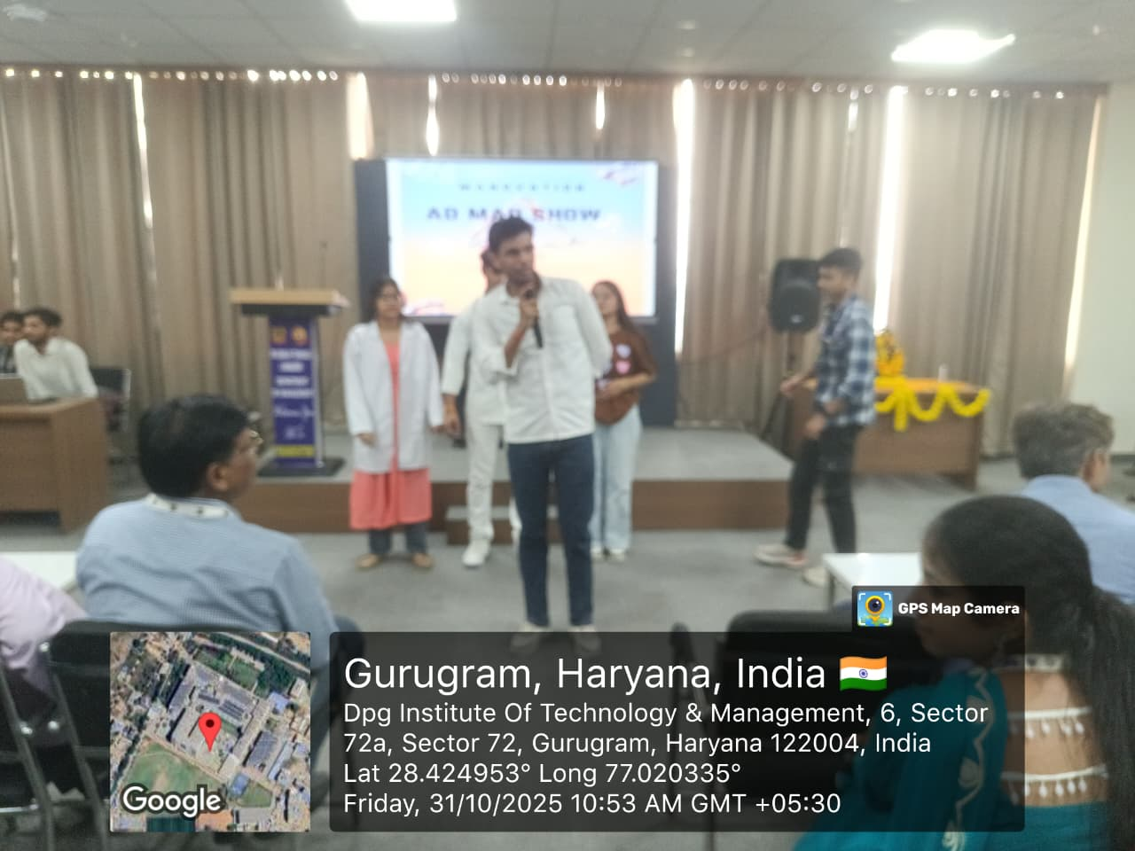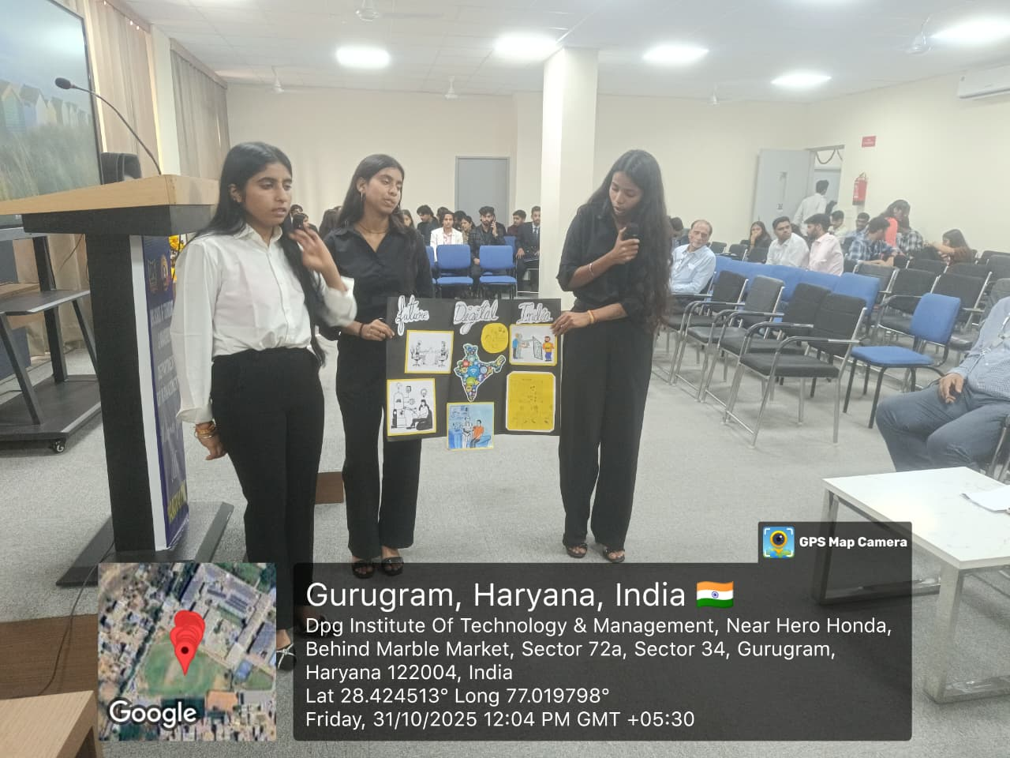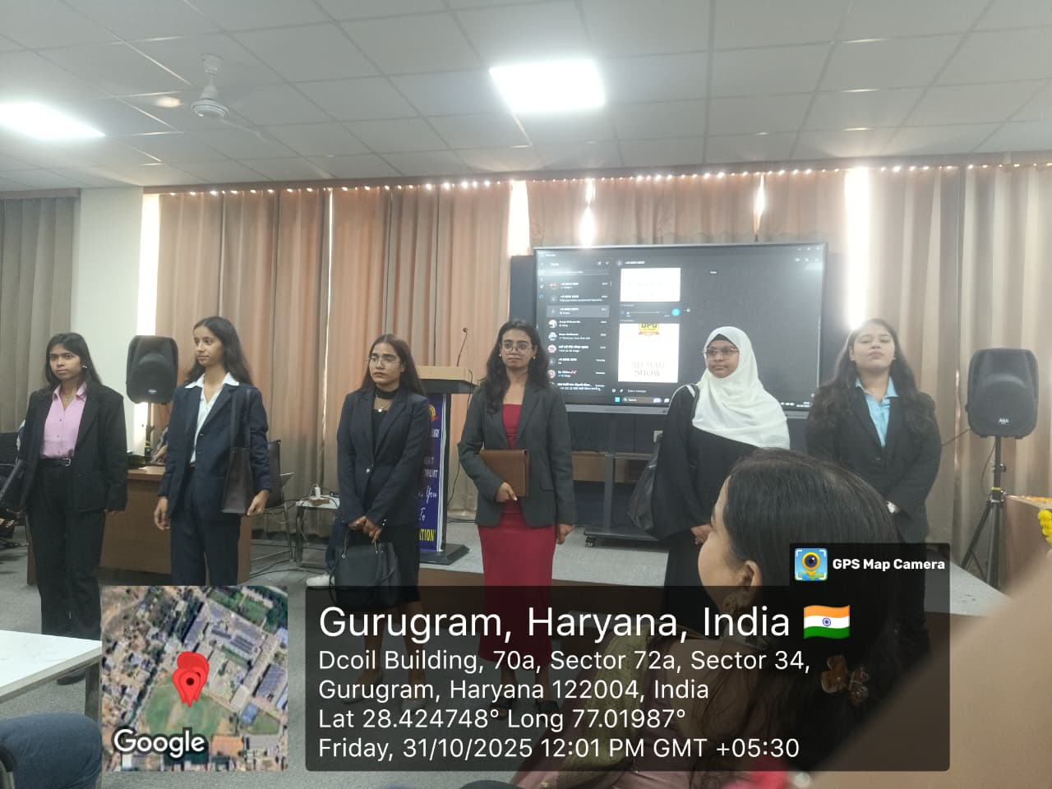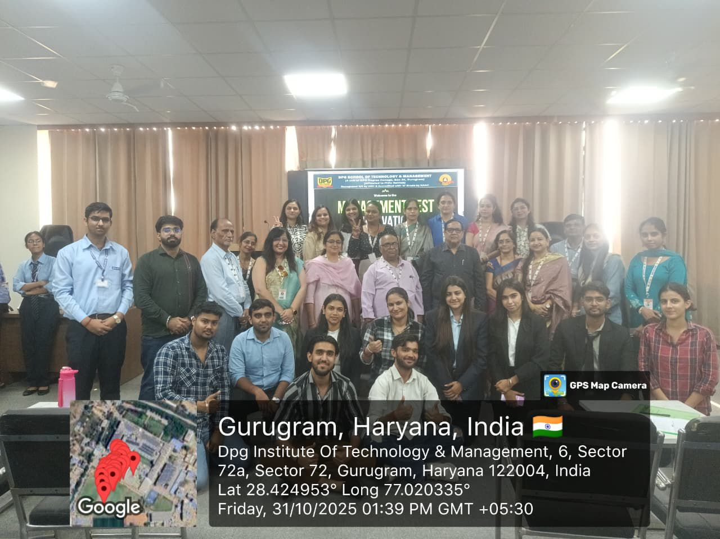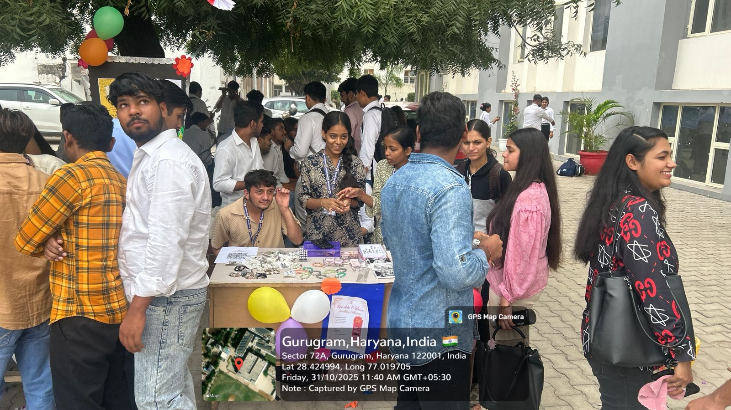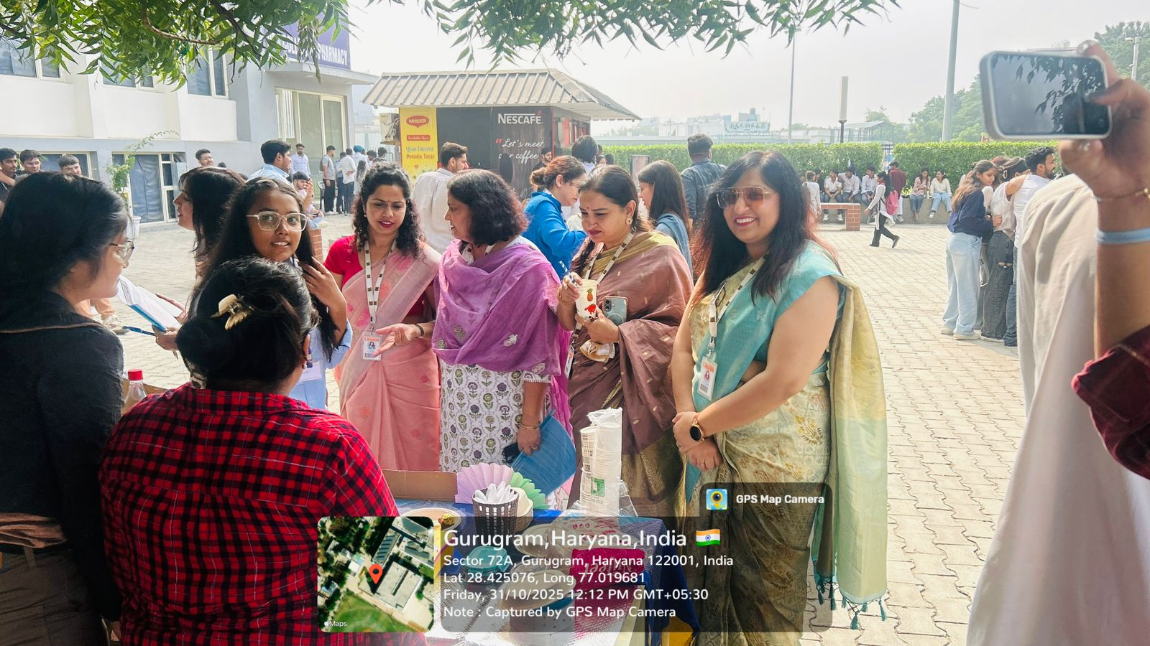

HOD Principal

