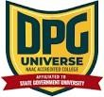
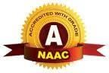
DPG DEGREE COLLEGE
(Approved by AICTE & Affiliated to MDU)
Recognized 2(f) by UGC & Accredited with ‘A’ Grade by NAAC
Sector-34, Near Marble Market, Gurugram 122001

VANDE MATARAM DAY CELEBRATION

Date-7 November ,2025

Report on Vande Mataram Day Celebration
Date: November 7, 2025
Venue: DPG Degree College, Gurugram
DPG Degree College celebrated Vande Mataram Day with great enthusiasm and patriotic fervor on Friday, November 7, 2025, at 10:00 AM. The event was organized on short notice to mark the 150th anniversary of the iconic national song "Vande Mataram", which holds a special place in India’s freedom struggle and national pride.
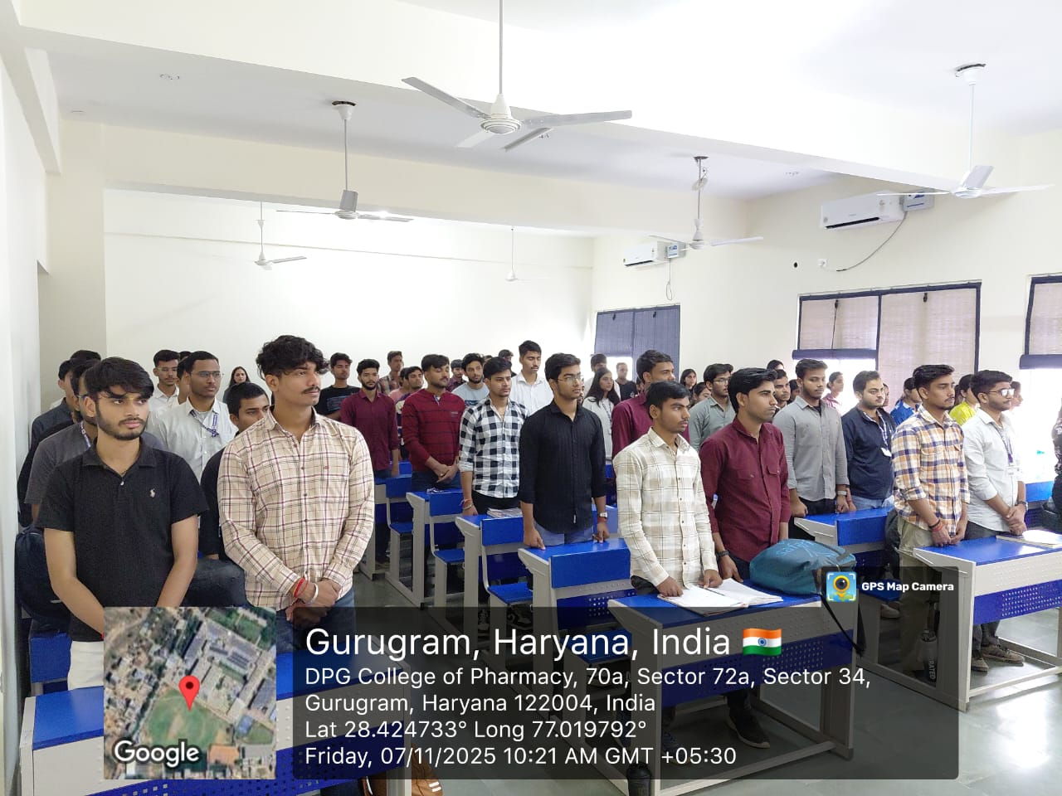
Due to the ongoing sessional examinations, the Polytechnic and Pharmacy Departments actively took the lead in conducting the event and extended their full support to make it successful. The program began with the melodious rendition of Vande Mataram, followed by speeches highlighting the historical significance of the song and its contribution to India’s independence movement.
Students and faculty members participated with immense zeal, expressing their respect and love for the nation. The atmosphere was filled with patriotic spirit as everyone joined in paying tribute to the legacy of Vande Mataram.
The event concluded with a vote of thanks, appreciating the collaborative efforts of the Polytechnic and Pharmacy Departments for their valuable contribution in organizing the celebration successfully within a short time frame.
Overall, the Vande Mataram Day Celebration at DPG Degree College was a grand success, reflecting unity, patriotism, and cultural pride among students and staff.
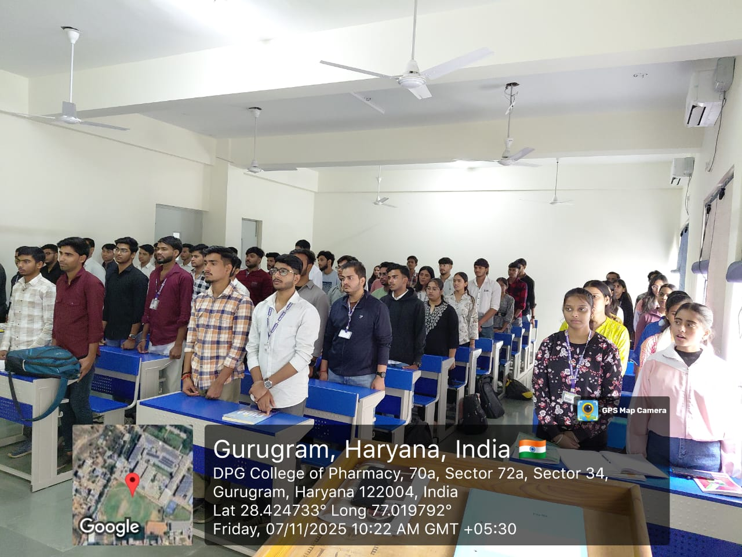

Ms. Navpreet Kaur | Dr. S.S. Boken
(Convener, Cultural Committee) | (Principal)
Asst. Professor, Department of Science | DPG Degree College

Dr. Kashmira Mathur
Assistant Professor, Department of Management
Ms. Kajal Gupta
Assistant Professor, Department of Management
Ms. Anjali Paliwal
Assistant Professor, Department of Management
Ms. Shruti Bhalla
Assistant Professor, Department of computer science
Dr. Shilpa
Assistant Professor, Department of physical sciences
Dr. Neha
Assistant Professor, Department of physical sciences
Ms. Chandni
Assistant Professor, Department of engineering
Ms. Renu Sharma
Assistant Professor, Department of Commerce
Dr. Sarita
Assistant Professor, Department of life sciences
Ms. Pooja Soni
Assistant Professor, Department of Arts & Humanities
Ms Arushi Jaiswal
Assistant professor, Department of Arts and Humanities

